Rob Carrico
• Texas: Austin, Dallas, Houston
• Virginia: Richmond, Charlottesville
• Alabama: Birmingham
Contact Information:
Office of Development
University of Georgia
Athens, GA 30602
Rcarrico@uga.edu
423.276.6537

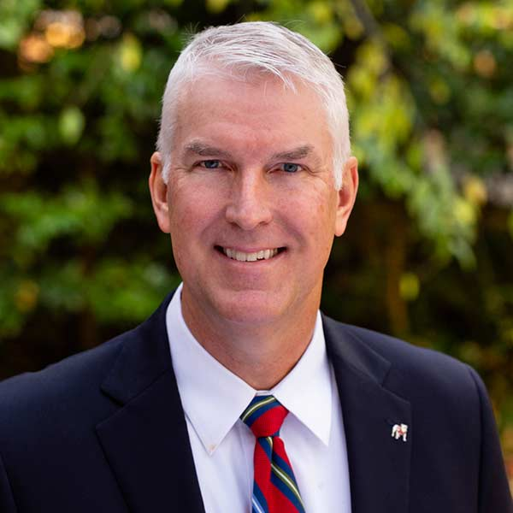
Chris Jefts
• Georgia: South Georgia, Rome, Dalton
Contact information:
Office of Development
University of Georgia
Athens, GA 30602
cjefts@uga.edu
770.815.8556

Elizabeth Kozak
• Tennessee
• Colorado: Denver
Contact Information:
Office of Development
University of Georgia
Athens, GA 30602
emg@uga.edu
478.737.3449

Matt Mize
• Florida: Jacksonville
• Georgia: Savannah, St. Simons, Greensboro, Macon, Augusta
• Kentucky: Louisville, Lexington
• South Carolina: Charleston, Hilton Head
Contact Information:
Office of Development
University of Georgia
Athens, GA 30602
mattmize@uga.edu
706.319.0074

Adam Prescott
• North Carolina: Charlotte, Raleigh-Durham
• Georgia: Atlanta, Columbus
• Illinois: Chicago
Contact Information:
Office of Development
University of Georgia
Athens, GA 30602
apresc@uga.edu
706.308.0704

Natasha Radojcic
• California: Los Angeles, Santa Barbara, San Diego, Bay Area
• Arizona: Phoenix
• Nevada: Las Vegas, Lake Tahoe
Contact Information:
Office of Development
University of Georgia
Athens, GA 30602
natasha.radojcic@uga.edu
415.860.4710
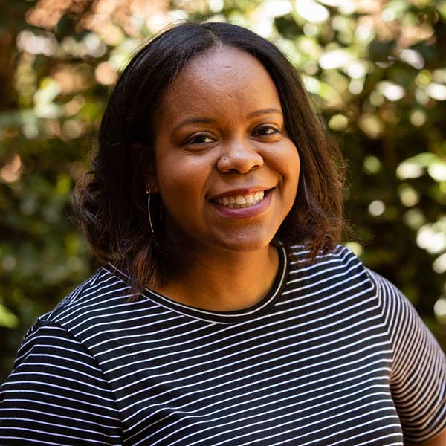
Bethany Glass
• Georgia: Atlanta
Contact Information:
Office of Development
University of Georgia
Athens, GA 30602
Bethany.Glass@uga.edu
601.832.9603

Adam Roell
• Florida: Tampa, Naples, Miami, Ft. Lauderdale, Palm Beach
• Massachusetts: Boston
• Georgia: Gainesville
Contact Information:
Office of Development
University of Georgia
Athens, GA 30602
aroell@uga.edu
770.307.6349

Alysse Whatley
• New York
• Connecticut
• New Jersey
• Pennsylvania: Philadelphia
Contact Information:
Office of Development
University of Georgia
Athens, GA 30602
alysse@uga.edu
678.481.4783

Beth Zimmerman, Senior Regional Director
• Missouri: St. Louis
• South Carolina: Greenville, Columbia
• Campus-wide Partnerships: Graduate School, Institute for Higher Education, Medical Partnership, Office of Diversity, Office of Global Engagement, Public Health, Willson Center
Contact Information:
Office of Development
University of Georgia
Athens, GA 30602
bethzimmerman@uga.edu
706.542.4001
Team: Rob Carrico, Chris Jefts, Matt Mize, Adam Prescott, Adam Roell

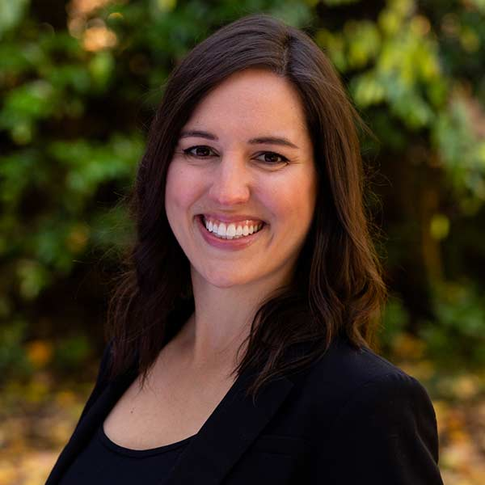
Siara Abdulla, Senior Regional Director
- Campus-Wide Partnerships: 60th Anniversary of Desegregation
Contact Information:
Office of Development
University of Georgia
Athens, GA 30602
siara@uga.edu
706.621.8725
Team: Bethany Glass, Elizabeth Kozak, Natasha Radojcic, Alysse Whatley

